CURRICULUM VITAE

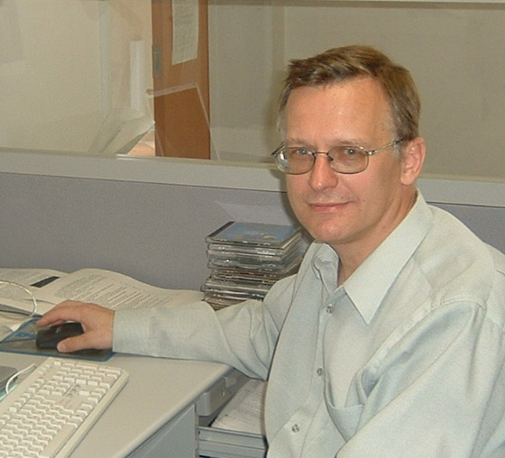
Name: VIACHESLAV A. PILIPENKO
Date and place of birth: June 07, 1950; Moscow
Nationality: Russian

Affiliation and official address:
Head of Laboratory “Physics of near-Earth Environment”
Institute of the Physics of the Earth
Russian Academy of Sciences

B. Gruzinskaya, 10
Moscow 123995, Russia

also – Full Researcher at Space Research Institute, Russian Academy of Sciences
Profsojuznaja 84/32, 117810 Moscow

Tel.:7-495-4383985 Fax: 7-495-2549088 Mobile: 7-903-6184666
E-mail: pilipenk@augsburg.edu pilipenko_va@mail.ru

Education:
* M.S. in Physics from Dept. of Physics, Moscow State University, 1973
* Ph.D. in Physics and Mathematics, Institute of the Physics of the Earth Russian Academy of Sciences, 1980 ("The role of drift instabilities in the excitation of geomagnetic ULF waves")
* Dr.S. in Physics and Mathematics, Space Research Institute of the Russian Academy of Sciences, 2006 ("Resonant effects of ULF waves in the near-Earth environment")
* Professor, 2014

Major fields of interest:
space plasma and solar-terrestrial relationships, wave and plasma processes in the terrestrial magnetosphere and ionosphere, solar wind-magnetosphere-ionosphere-atmosphere coupling, man-made modifications of the ionosphere, earthquake prediction

Career/Employment and Professional Experience:
1992-present Head, Laboratory of “Geomagnetic ULF waves”, Institute of the Physics of the Earth, Russian Academy of Sciences (Moscow)
1980-1992 Full Researcher, Institute of the Physics of the Earth, Moscow
1975-1980 Associate, Institute of the Physics of the Earth, Moscow
1973-1975 Assistant, Institute of the Physics of the Earth, Moscow

Knowledge of foreign languages - English (fluent), Italian (weak)

Professional experience:
- data analysis and theoretical interpretation of satellite and ground-based observations of ULF waves;
- theory of plasma instabilities and MHD waves in the near-Earth environment;

Publications:
- number of papers in refereed journals: >200
- number of invited and contributed presentations to scientific meetings: >70

Teaching experience:
- Courses on space plasma physics and “Secrets of physicist’s kitchen” – Augsburg College (MN), 2002-2008;
- Course on space weather physics – Nagoya University, 2009;
- Course on cosmic electrodynamics – Kuyshu University (Japan), 2003.

Programming skills: FORTRAN and scientific packages (IDL, MATLAB)

Ph.D. students: 7
Kurneva N.A. “Influence of magnetospheric resonance effects on spatial structure of ULF waves”
Pikalkin V.Yu. “Synchronous ionospheric Doppler and ground magnetic observations of ULF signals”
Martines-Bedenko V.M. “Dynamical analysis of spatio-temporal structure of disturbances of terrestrial geomagnetic field”
Chugunova O.V. “Pc3-4 pulsations in the polar cap”
Chizenkov V.A. “Relationships between Kosmos satellite failures and helio-geomagnetic disturbances”
Romanova N.V. “Statistical relationships between the satellite anomalies and high-energy radiation in near-Earth space”.
Belakhovsky V.B. "Wave processes in the Pc5 band in the magnetosphere and ionosphere"

Honors, Awards, Fellowships, Membership:
- Member of American Geophysical Union since 1989 (#09840216)
- Member of Japanese Geophysical Union since 2006 (#017959)
- Corresponding member of Russian Academy of Natural Sciences (since 2000)
- Russian state medal “850 Anniversary of Moscow”
- Medal from the International Biographical Center, Cambridge England “Outstanding Scientists of the 21-st Century”

Personal:
Home address: Russia, Moscow 117513, Leninsky pr., 123-3-184
Marital status: married since 1973
wife - Shuvalova Natalia, born in 1950, Senior Researcher in the Institute of Informatics of the Russian Academy of Sciences.
son - Pilipenko Oleg, born in 1980, manager of COVERALL company, Canada.

